HOW I HACKED MY UNIVERSITY WEBSITE WITH MAGICAL WORDS

Author: Humna Imran
Institution: The University of Faisalabad

Target Scope: http://example.com/products.php?id=1
I used a purposely vulnerable demo URL (Only for this Document). This endpoint mimics a product details page with a SQL-vulnerable id parameter.

Phase 1: SQL Injection Detection

Command
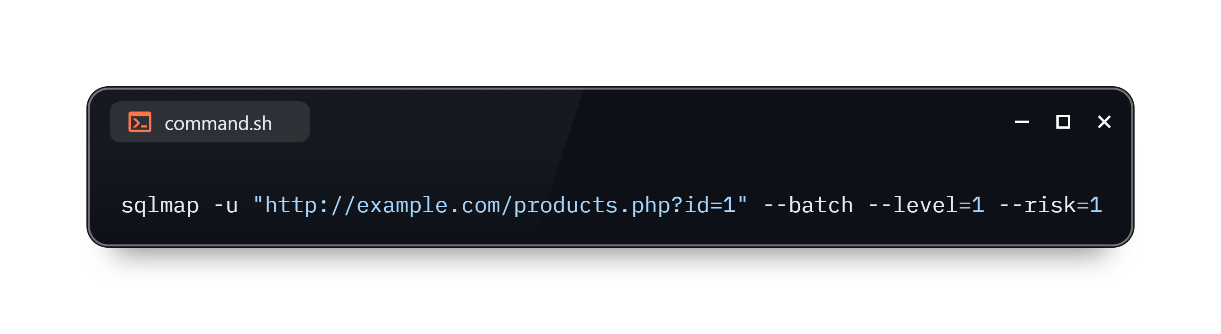
Running this basic sqlmap scan helped me verify that the id parameter was indeed injectable. sqlmap identified the backend as MySQL and suggested a boolean-based injection point. I used --batch to avoid prompts and keep the scan automated.

Takeaway
The initial detection was quick and efficient. I saw firsthand how even a low-risk scan can expose a serious vulnerability.

Phase 2: Manual Union-Based SQLi (via Burp Suite)

Manual Payload
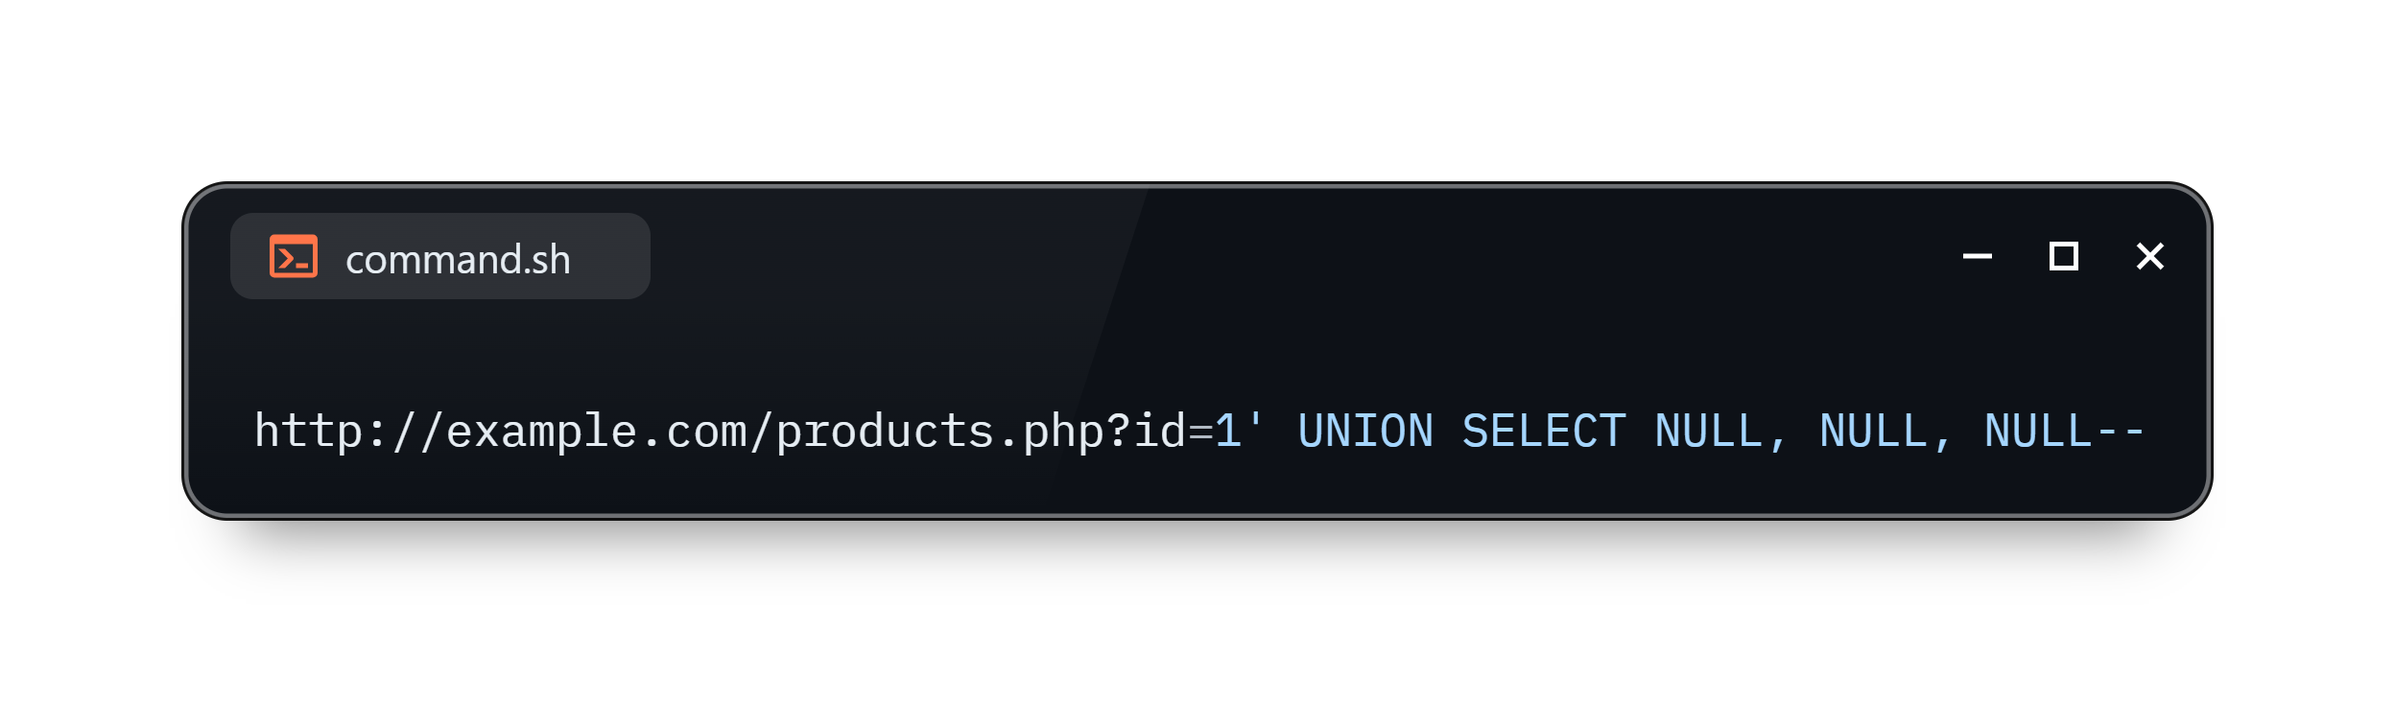
I intercepted the request using Burp Suite and manually altered the payload. After several attempts, I discovered that the application responded differently when the number of NULL values matched the column count, confirming a union-based vulnerability.

Observation
The page loaded differently, and in one test, it even printed test values, which proved that my payload was working.

Phase 3: Boolean-Based Blind SQLi

Tool: sqlmap

Command
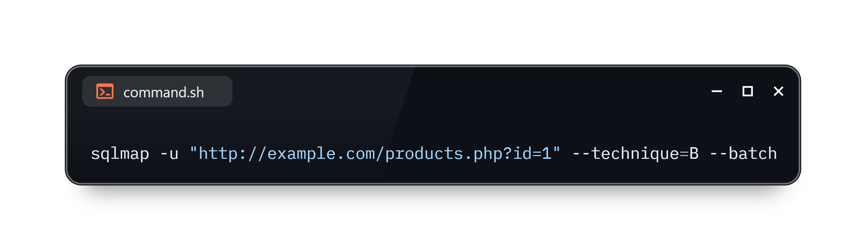
Here I restricted sqlmap to only boolean-based techniques. This test was slower but effective — I could see how the tool was relying on logic-based responses (True/False) to infer data.

Realization
Even when the app shows nothing visually, data can still be extracted by observing behaviour, a true “blind” approach.

Phase 4: Time-Based Blind SQLi

Command
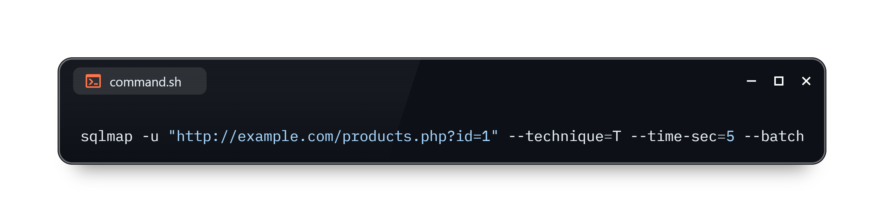
I deliberately injected time delays into the SQL queries to measure server response. sqlmap used this technique to confirm injection, and I observed a consistent 5-second lag, indicating that the queries were being executed.

Key Moment
Watching a server delay as proof of injection was eye-opening. It felt stealthy, no visible output, just time-based proof.

Phase 5: Error-Based SQLi (Manual)

Payload Used
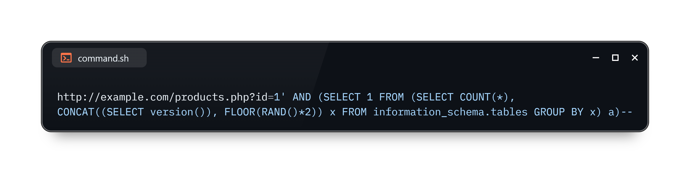
When I tested this payload in Burp, I received a MySQL error exposing the version number. That error message gave me system-level insight, including the structure of some internal database tables.

Eye-Opener
A single crafted query led to a massive leak. This was one of the most dangerous payloads I tested.

Phase 6: WAF Bypass Techniques

Command
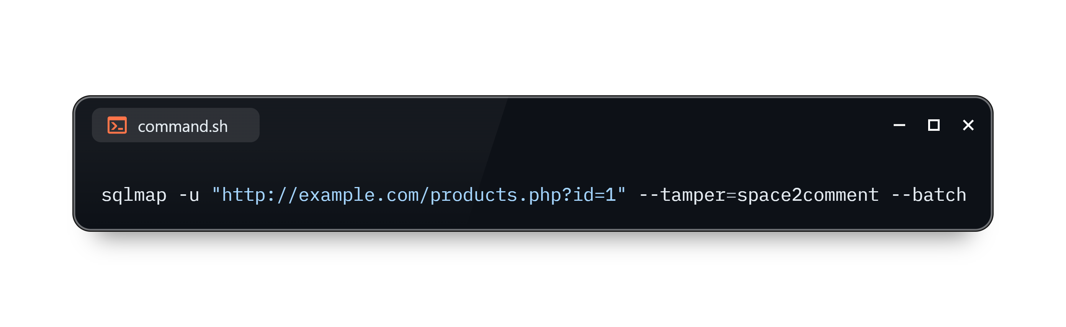
To simulate a protected environment, I enabled a basic WAF. Using --tamper=space2comment, sqlmap evaded it by inserting SQL comments (/**/) in place of spaces. The bypass worked — the injection succeeded even with the WAF on.

Lesson Learned
Tamper scripts are incredibly powerful. WAFs that rely on signatures can be easily fooled.

Phase 7: Database Enumeration

Command
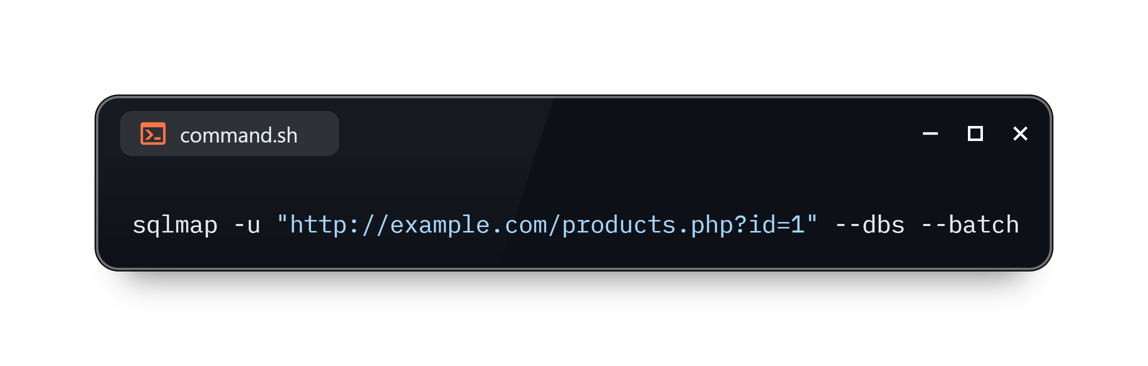
sqlmap returned a list of databases, including information_schema, test_db, and users_db. It was a solid demonstration of how an attacker could pivot from access to full enumeration.

Phase 8: Post-Exploitation – Table & Data Extraction

Command (List Tables)
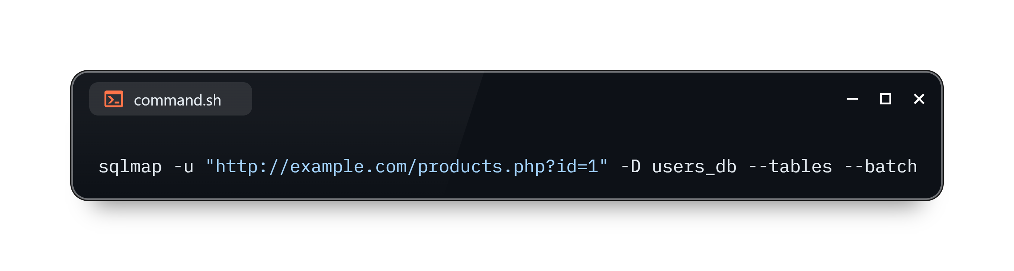

Command (Dump Data)
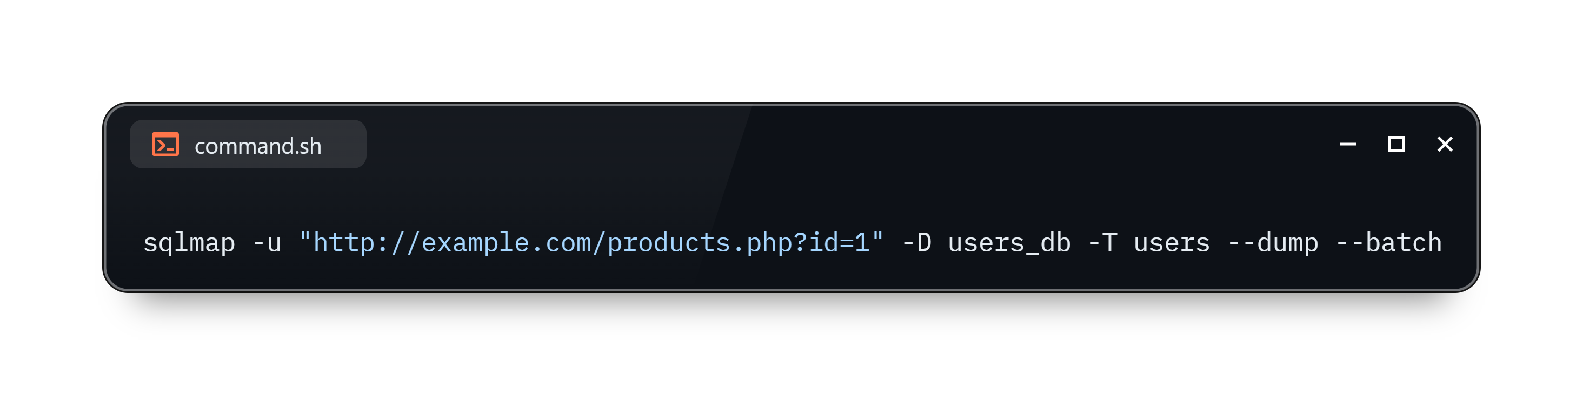

I successfully manipulated fake user data, including names, emails, and even password hashes. This felt like a full compromise of the web application. Thankfully, this step was performed on a separate webpage and could be easily undone; otherwise, it would have been catastrophic.

This showed me how SQL injection can move from discovery to data exfiltration in just a few steps. Even without advanced access, I could manipulate the backend using tools like sqlmap and Burp Suite, all from a single vulnerable parameter.

Thank You

